# 003. Add gui transaction (using Program) to the fiori launchpad

need to add new tile in CODEINMINS Custom Apps

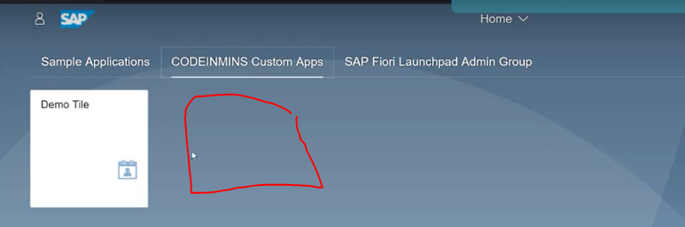

## 1. create the program in se38

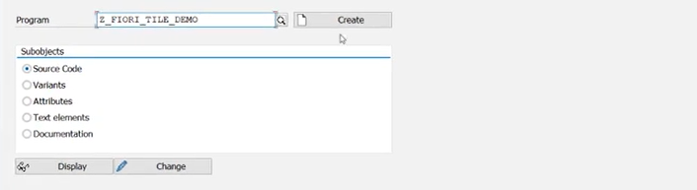

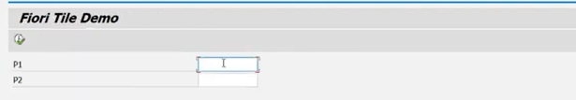

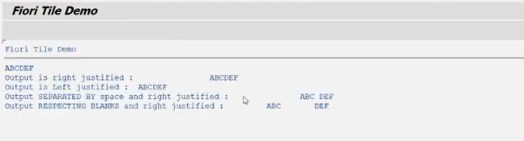

create tcode:

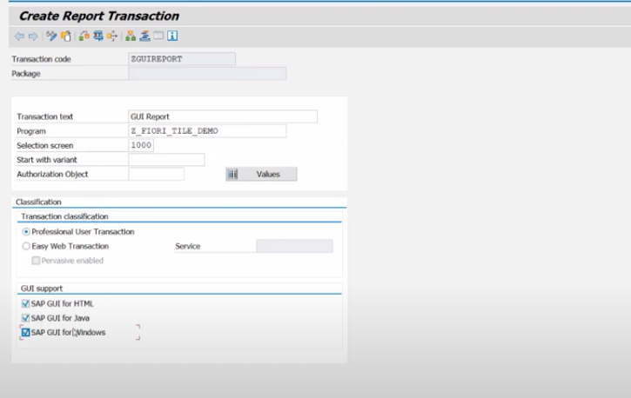

## 2. Now we need to create the tile using the fiori launch pad admin group tab.

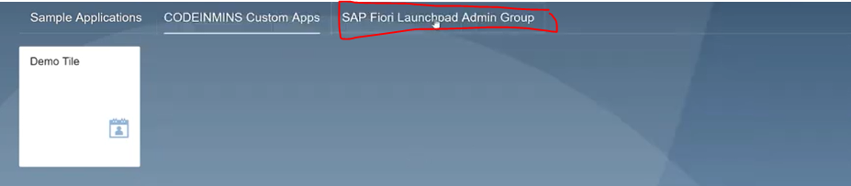

Next click on Fiori launchpad designer

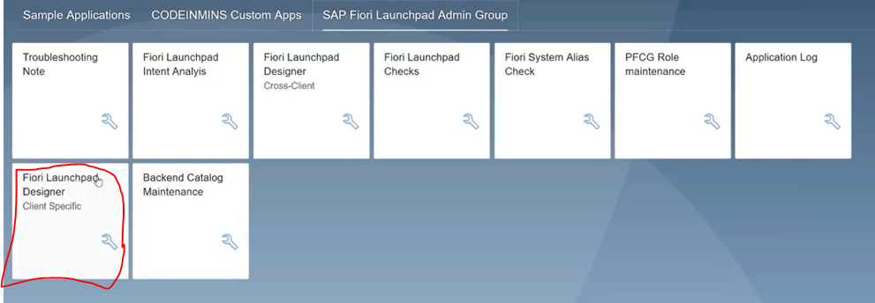

when you click on FLPD designer --> you can launch it below screen

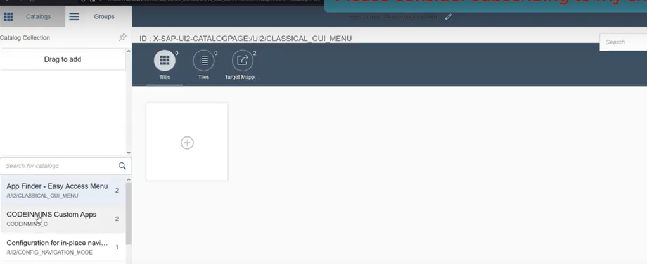

already we have created the catalogue and group

catalogue :CODEINMINS_C

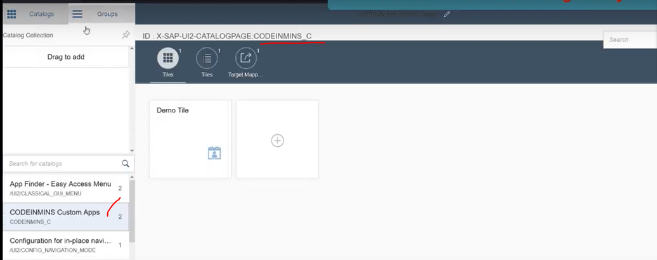

Need to create the new sematic object: go to /ui2/semobj

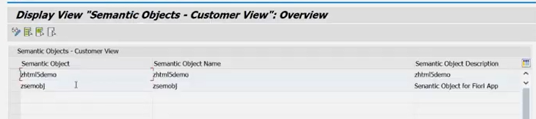

click on change mode

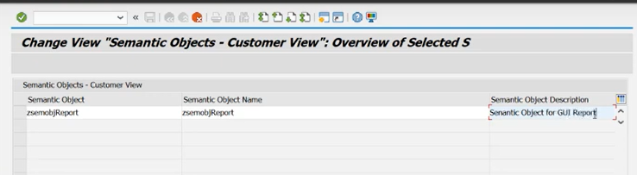

press enter --> click on save --> and stored in NEW TR.

now new semantic object created.

## 3. Now create the tile from the catalogues/ groups:

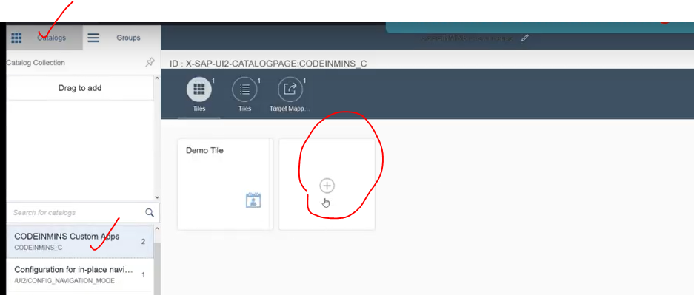

click on + Button.

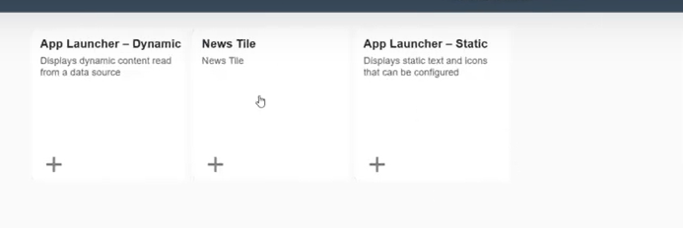

click on static tile.

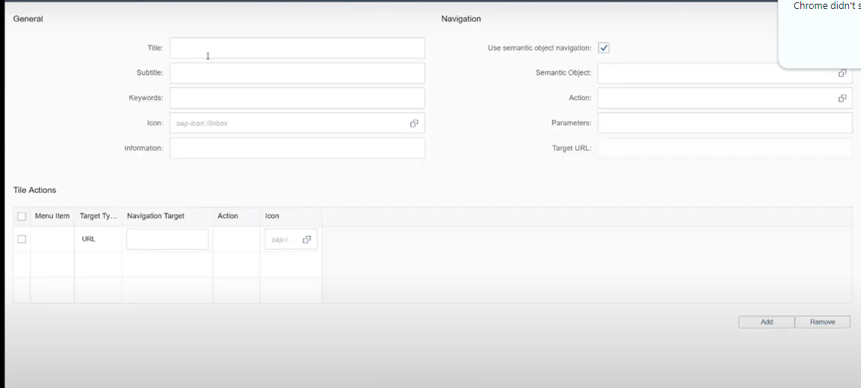

fill the details

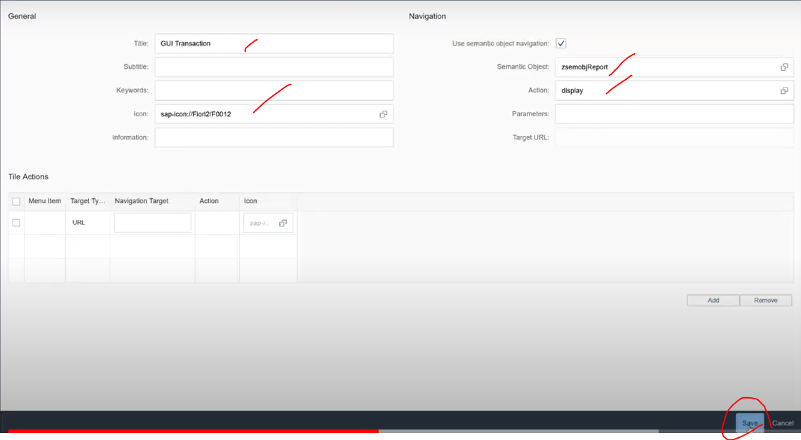

click on save button

Now tile has been created under the catalogue.

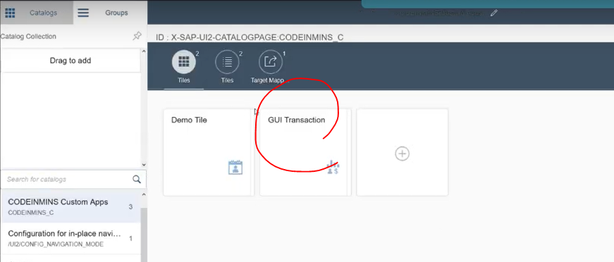

let create the target mapping --> click on target mapping

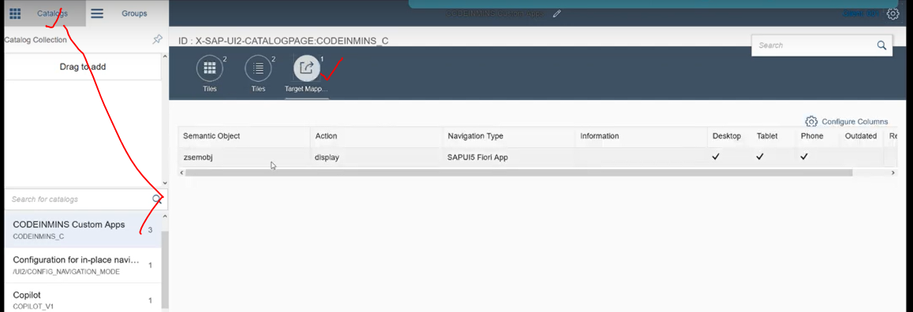

again click on create target mapping

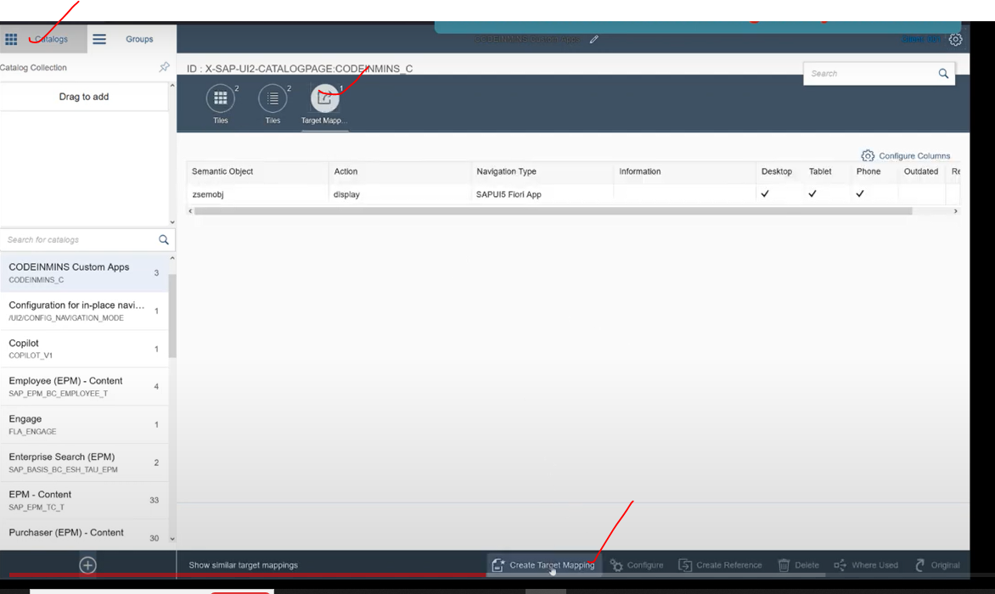

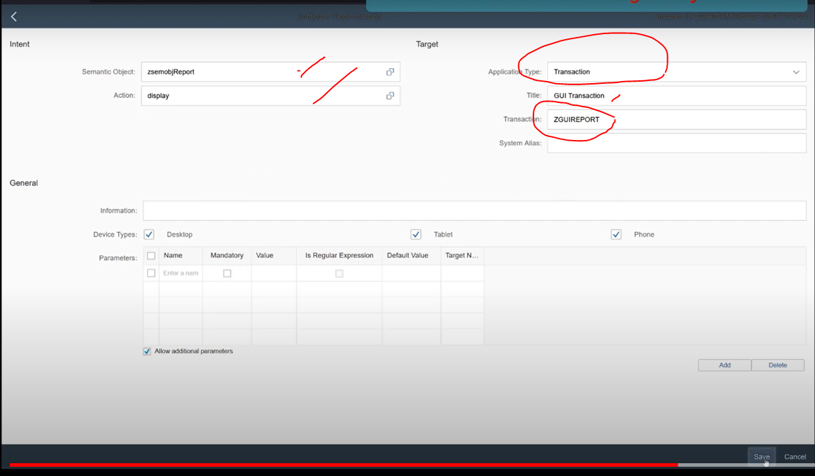

click on SAVE

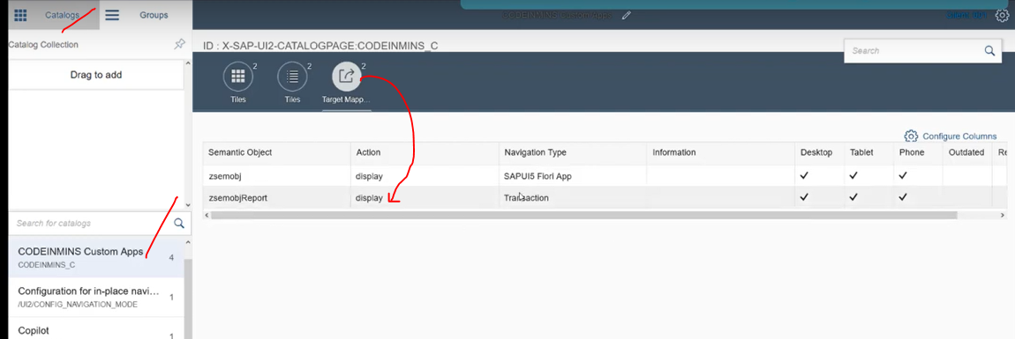

Now we need to go to the groups tab

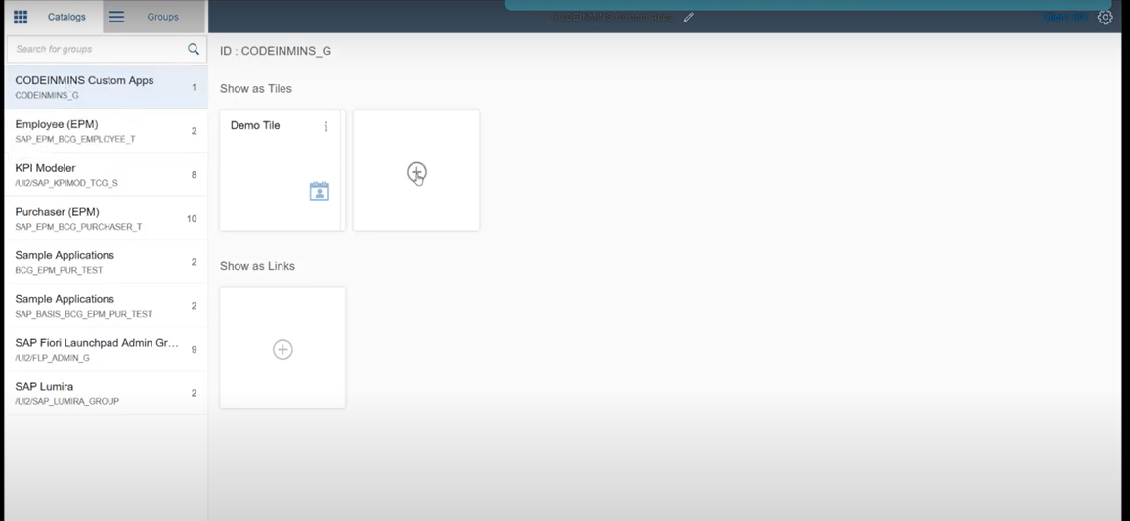

now click on + button, to activate the tile/catalogue at group level.

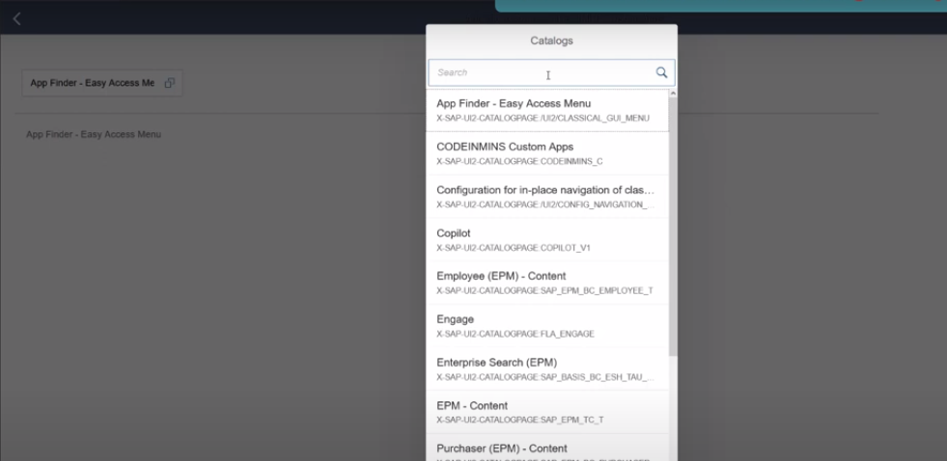

search our catalogue.

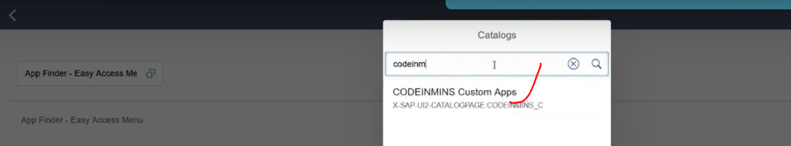

select it.

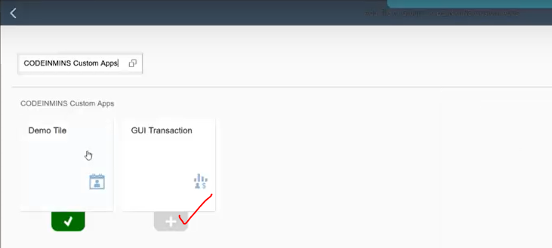

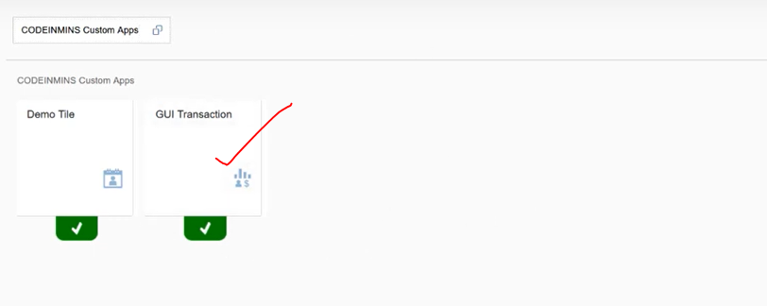

now tile activated

## 4. Now run the fiori launchpad. see the tile.

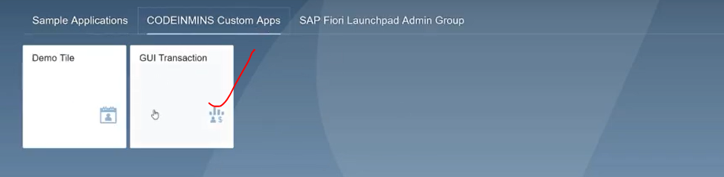

Now click on gui transaction

